AutoEmail Full Installation Tests
Tester: Tony Tasker
Date: 19th January 2017
Time: 14:00
PC/Server: TonyTasker-PC
Database: Simmons_V7_Test (Copy of live Simmons and Simmons DB)
Works Summary: N/A
Works Order: N/A
Task: N/A
Notes: These tests were performed using Microsoft SQL Server Management Studio. Output to the Results and Messages Output Windows are used to determine the success of the tests. Also the receipt of emails.

Testing implementation to email AEFCON

Pre-Test Setup
No | Task | Tester | Pass | Notes
1 | In X CABS Config, Section CABS_AUTO_EMAIL_FUNCS if WIPWindow is set then  WIPWindow=0  Set DebugFlag=1  In section CABS_AUTO_EMAIL_FUNCS_Trigger  Set DebugFlag=1 | TT
2 | In X CABS Config, Section AEFCON change setting  Frequency=D:1;H:0;M:3;W:1;S:0;T:0730;L:B4;  to  Frequency=D:0;H:0;M:3;W:1;L:CR; | TT

Post-Test Setup
No | Task | Tester | Pass | Notes
1 | Reverse any Config Changes in X CABS Config | TT

Tests

Booking Confirmation – AEFCON
No | Test | Tester | Pass | Notes
1 | In CABS locate a function to test with:  SELECT * FROM FUNC_FIL INNER JOIN MBRFILE ON F_MBR_NO = MBR_SYSNO  WHERE MBR_IMPKEY IN (SELECT MBR_IMPKEY FROM MBRFILE  GROUP BY MBR_IMPKEY  HAVING COUNT(MBR_IMPKEY) = 1) and F_DAY > GETDATE() and F_STATUS = 'PROVNL'  Using F658476  Ensure correct classification  Ensure following settings are set in System Defaults, Section AEFCON:  SendToSpecific=1 | TT |  | There is an issue with data in the MBRFILE table such that MBR_IMPKEY is not unique.
2 | Update the status of the Function to CONFRM  UPDATE FUNC_FIL SET F_STATUS = 'PROVNL' WHERE F_REF = 'F658476'  Check status of AutoEmail Queue  SELECT * FROM vw_AEFLINK WHERE AEFL_FREF = 'F658476' | TT |  | For Email Template AEFFFC:  AEFL_CanSend should be 1,  AEFL_Sent should be 0,  SessionSendable should be 1,  Sendable should be 1,  MatchCriteria should be 1
3 | Process the AutoEmail  EXEC CABS_AUTO_EMAIL_FUNCS_SESS_CHECK | TT |  | Email delivered as per Figure 1

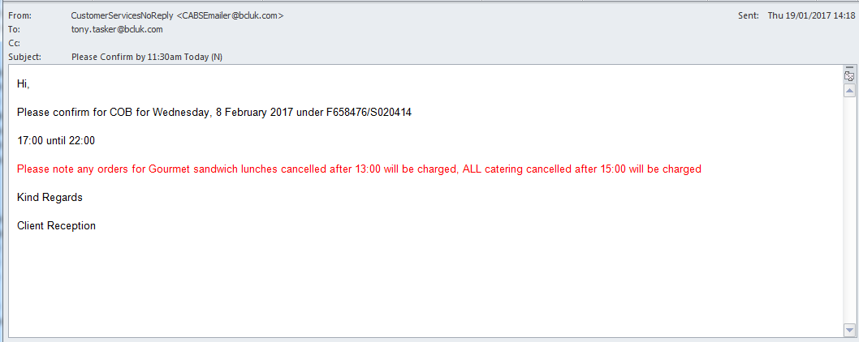
Figure 1 – Booking Confirmation Email

Booking Confirmation Email (AEFCON) Scheduled Correctly

No | Test | Tester | Pass | Notes
1 | In X CABS Config, Section AEFCON change setting  Frequency=D:0;H:0;M:3;W:1;L:CR;  to  Frequency=D:1;H:0;M:0;W:1;S:0;T:0730;L:B4; | TT
2 | Update the status of the Function to CONFRM  UPDATE FUNC_FIL SET F_STATUS = 'PROVNL' WHERE F_REF = 'F658476' | TT |  | For Email Template AEFFFC:
3 | Check AutoEmail SendTime  SELECT AEFL_SendTime FROM vw_AEFLINK WHERE AEFL_FREF = 'F658476' | TT |  | AEFL_SendTime is set to 2017-02-07 07:30:00:000
4 | Get the Booking Start Date  SELECT F_DAY FROM FUNC_FIL WHERE F_REF = 'F658476' | TT |  | F_DAY is set to 2017-02-08
5 | Ensure AEFL_SendTime is correct according to Frequency setting | TT |  | F_DAY is set to 2017-02-08  AEFL_SendTime is set to 2017-02-07 07:30:00:000  Frequency is configured to D:1;H:0;M:0;W:1;S:0;T:0730;L:B4;  Autoemail due to be sent on the day before the function at 07:30

